Mithibai College

Department of Computer Science

Practical-8 Cyber Forensics Image analysis using Autospy

**System Security & Digital forensics Date:- 26/06/2022**

**Writeup:-**

* **Autospy**
* **Phases of cyber forensics**
* **Features of evidences**
* **Challenges in Cyber Forensics**

Create Forensic images of digital devices from volatile data such as memory using Images from Computer System

STEP1: Create new case here.

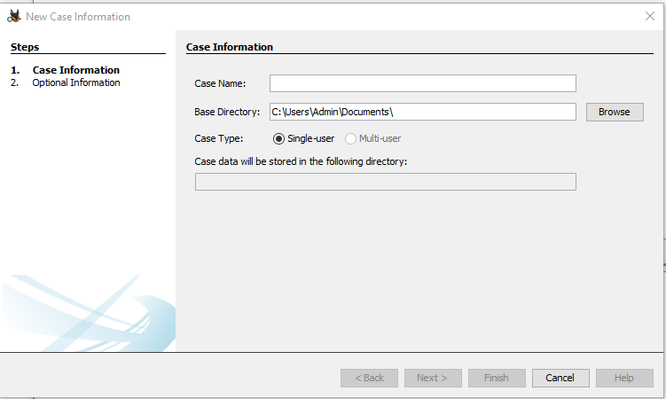

STEP2: After clicking new case, fill in the required information like a case number and base directory and all the necessary information.

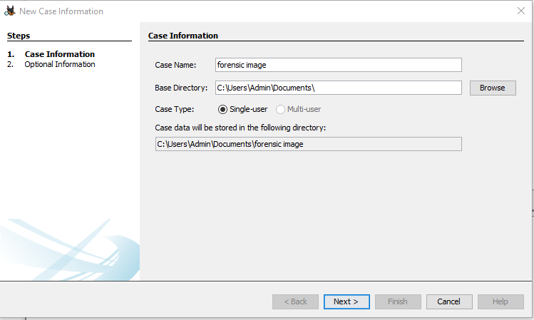

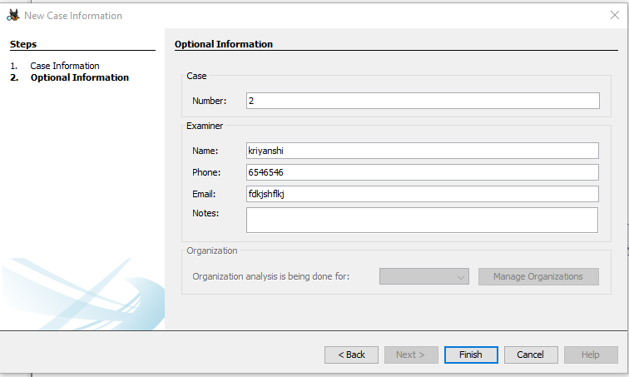

STEP3: Now, after filing the information we will be present at this screen where we have to select add source and then select the host. Use Generate new host to generate new host for new cases.

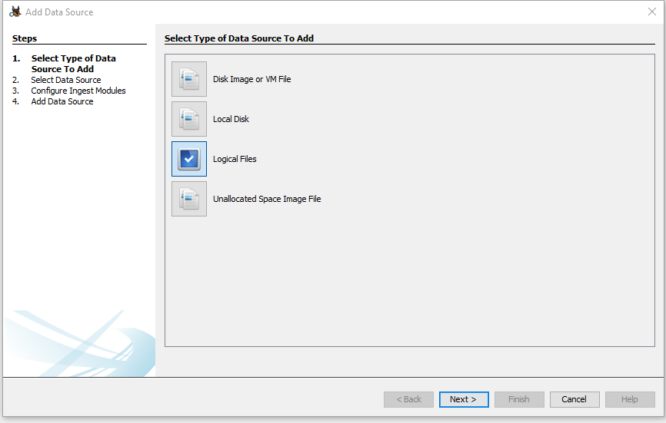

STEP 4: Now we have to select the type of source we are adding. In this demo, I am adding a Disk image file so I will select first. Then click next.

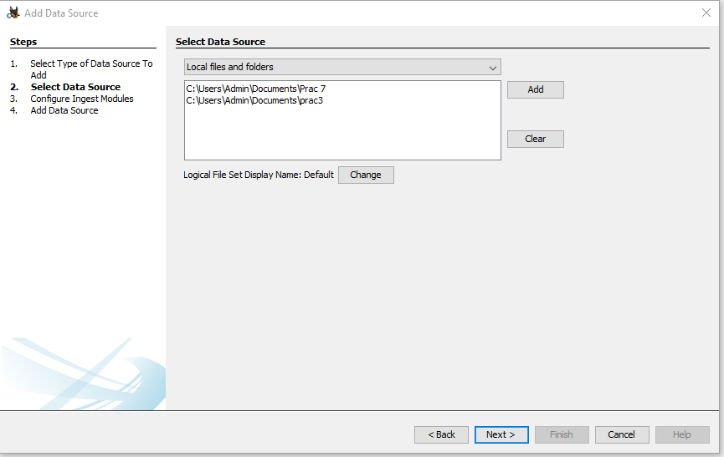

STEP 5: Here we have to select the location of the image file which we have to analyze. Then click next

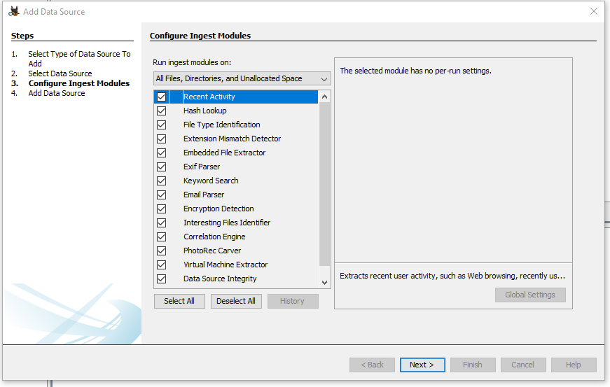

STEP 6: Never select all the ingest when analyzing a big file because it may take a lot of time to Ingest

Now it will analyze the ingest and give you the result.

Like this how we can analyze the deleted files from the disk this process is known as File Carving and we can do it that easily on the autopsy.

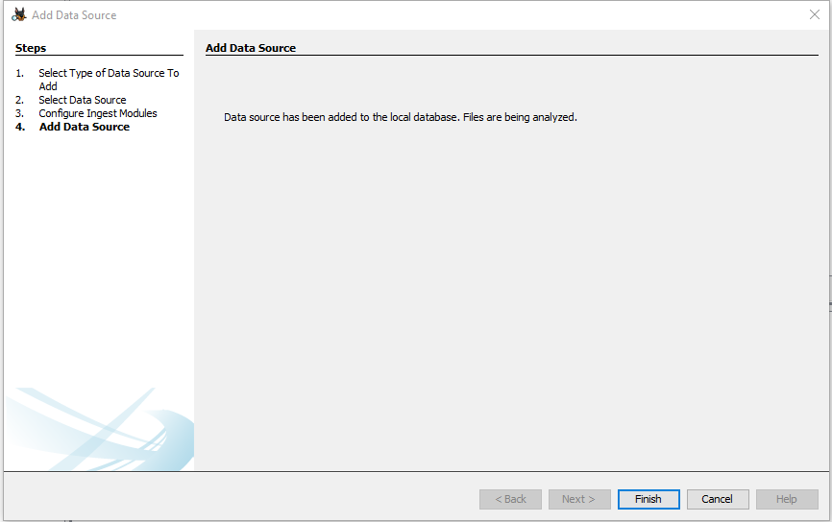

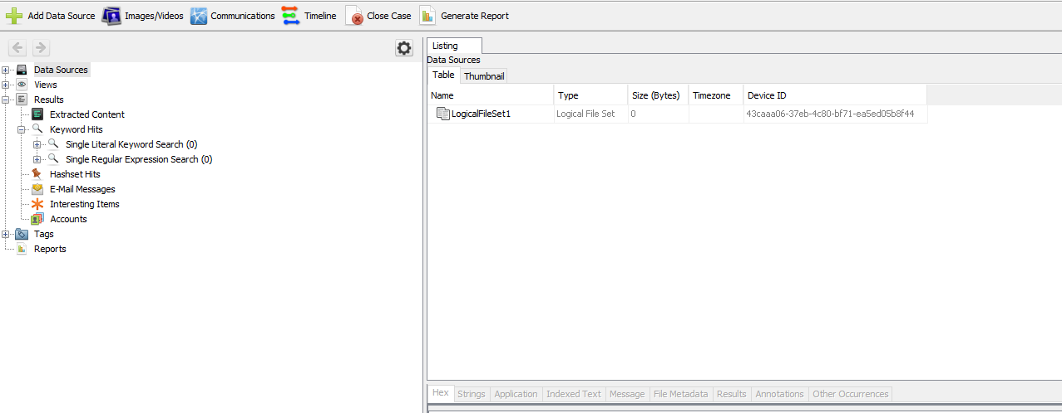

STEP7: Save in export folder and then extract it.

